School of Integrated Technology, Yonsei University

Course: Special Topics in System Engineering.

Homework 2
due date: before class on the 24th March
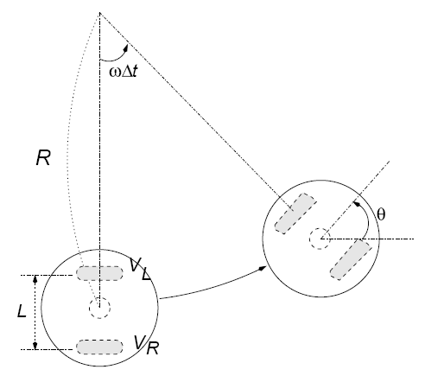

Figure 1. Robot system and kinematics in simulation

From the previous homework, we found the kinematics equation for the movement of this
robot. In this homework, we will simulate the two-wheeled robot with MATLAB. The robot controls each of the two wheel motors with an appropriate speed and thus the robot is exploring a given arena.

Suppose that the robot has 55 mm diameter and the length of wheel base, LB is 50 mm. And robotic movements follows the motor commands with the time step Δt = 0.1 sec. You need to calculate ω and R using parameters, LB and two motor speeds VL and VR. The robot’s head angle is changed by θ=ωΔt every time step. That is, if the current head angle is α, then next time step the head angle of the robot is α+ θ. You need to keep monitoring the centre position of the robot as well as the head angle.

The robot controller will issue the motor commands (L, R) of motor speeds to the motor
system. The motor commands will vary in time course randomly.

You can set up the initial position and initial head angle on your own choice. The L and R
values indicate the reference angular speeds of the motor in the control system. The transient angular speed of left motor is WL and then the linear velocity of left wheel on a floor should be calculated with VL = r WL, where r is the radius of the robot wheel. The left wheel of the robot moves in a distance of r WL Δt mm after Δt seconds. We assume the time step Δt is 0.1 second. Apply the kinematics equation with the transient linear velocities (VL VR ) for left and right wheels to simulate the robotic movement.

For random exploration, you can set the motor commands with the MATLAB command, for example,

L=rand*10; R=rand*10;

Apply new random motor commands every 1, 10, and 100 time steps. Draw the trajectories of robotic movements in the floor space for 1000 time steps. Also show a graph of transient angular speeds of the two motors in time course for the random exploration behaviour. You may assume that the robot wheel motors almost immediately follow motor command speeds with little transient time.

For robot trajectory drawing, show the trace of robotic movements (a sequence of centre position) for each case. You need to design MATLAB codes to show the animation of robotic movements. Please refer to the code as written below:

x = rand * 10; y = rand * 10 + 50; %initial positiob
head = 0; %initial head angle
hold off;
for i = 0:0.1:10,
t = 0:0.1:2*pi+0.2;
r = 55/2; % robot radius
x = i*10; %x position change
rx = x + r * cos(t); ry = y + r * sin(t); % robot drawing
head = i * 0.2; %change head angle
plot(rx,ry); % draw robot body
hold on;
line([x x+r*cos(head)], [y y+r*sin(head)]) % mark head
axis([-100 250 0 250])
pause(0.01); %you can control the speed of animation with this
hold off;
end;

Submissions
(1) Make the simulation program that robot moves randomly for each step in the map. Plot the trajectory of the robot.

(2) Repeat problem (1), but this time, apply new random motor commands every 10 time steps. Plot the trajectory of the robot.

(3) Apply new random motor commands every 100 time steps and simulate again. Plot the trajectory of the robot.

You need to write a report in English for the above results and your program code (12pt font is recommended, and please follow the instructions given in the course syllabus) and add the source codes you have modified and the result at the end. You should submit MATLAB codes in the YSCEC website.

